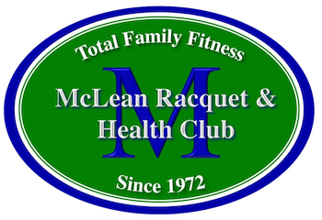 Pickleball pricing per hour
Private Lessons
Debbie: Nancy:
Member Non-Member Member Non-Member
$100 $120 $70 $80
Semi-Private (2 on1) Per person
Member Non-Member Member Non-Member
$60 $70 $45 $55
½ hour private
Member Non-Member Member Non-Member
$60 $70 $45 $55
3 person clinic
Member Non-Member Member Non-Member
$45 $50 $40 $45
4 person clinic
Member Non-Member Member Non-Member
$35 $40 $35 $40
Kids Clinics (4 -1 with an assistant) – 3 week session
Member Non-Member Member Non-Member
$75 $90 $75 $90
Per week kids (4-1 with Assistant)
Member Non-Member Member Non-Member
$30 $35 $30 $35

